DO NOT USE YOUR NOTES. Discus among yourselves and check with your TA before you move on.

1. What structural features do you look for when you are trying to decide whether carbon center is electrophilic (or can act as a Lewis acid) Give examples to show what you mean

2. What structural features do you look for when you are trying to decide whether a substance is a nucleophile. Give examples to show what you mean.

3. What are the requirements for a good leaving group? Give examples to show what you mean.

4. Complete these reactions: draw out a full structure for the reactants, identify the electrophilic center and the nucleophile, draw a mechanism with curved arrows to help you predict the products and draw the products. Identify the functional group that is produced for parts a and b (you do not have to name the compound itself)

a. CH3CH2O– + CH3CH2CH2I 🡪

b.

(hint, recall that it is possible to rotate around C–C single bonds)

c.

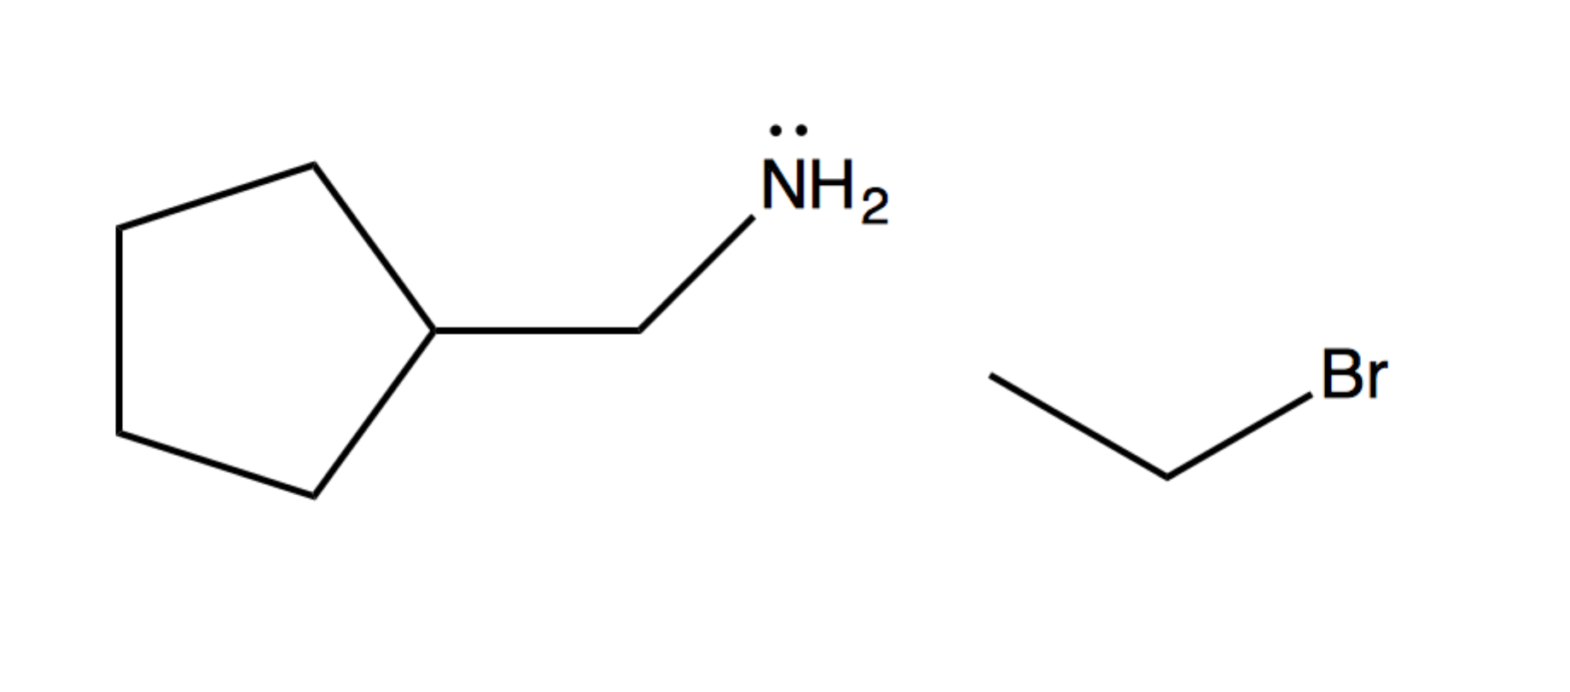

d.



5. What reactants might react to give these products? (draw out the full structures of the products and concentrate on the bond formation reactions that you know)

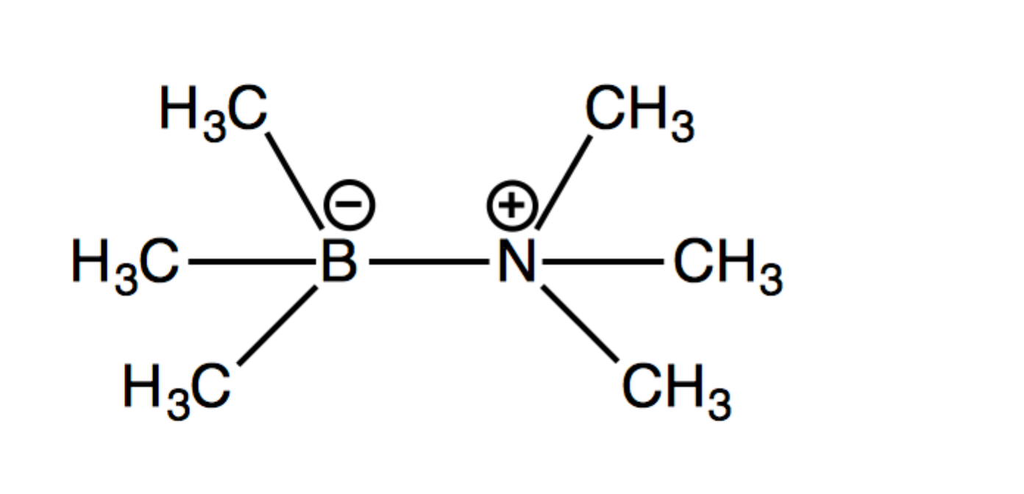

a. 🡪

b. 🡪 CH3CH2OCH3 + Br–

For Homework

Write a letter to a friend who is struggling in organic chemistry to teach them how to use curved arrows to draw reaction mechanisms. Be sure to include some examples, and to discuss why we use these arrows and what they represent.